CSA1509-Cloud computing and Big Data Analytics
Name : p preethi
Reg.no: 192521178

EXP 14 : Demonstrate virtualization by Installing Type-2 Hypervisor in your device, create and configure VM image with a Host Operating system (Either
Windows/Linux).
Aim:
To Create a Virtual Hard Disk and allocate the storage using VM ware
Workstation.
Steps:
- Download VMware software and install it as Type-2 Hypervisor.
- Download Ubuntu or tiny os as ISO image file.
- In VMware workstation Create new VM
- Do the configuration based on given conditions
- Created a virtual Machine .
- Launch the VM.

Implementation:
- Download and open VMware software.
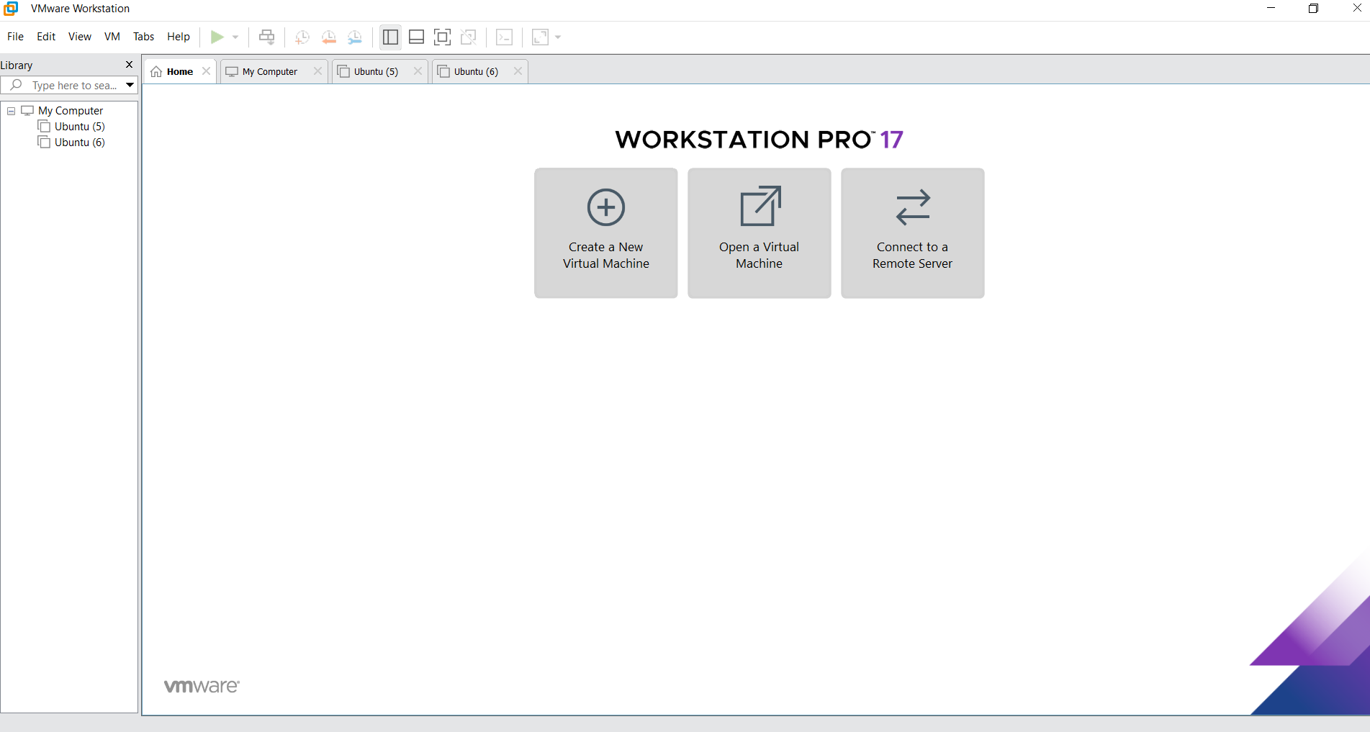
2.Create a new VM

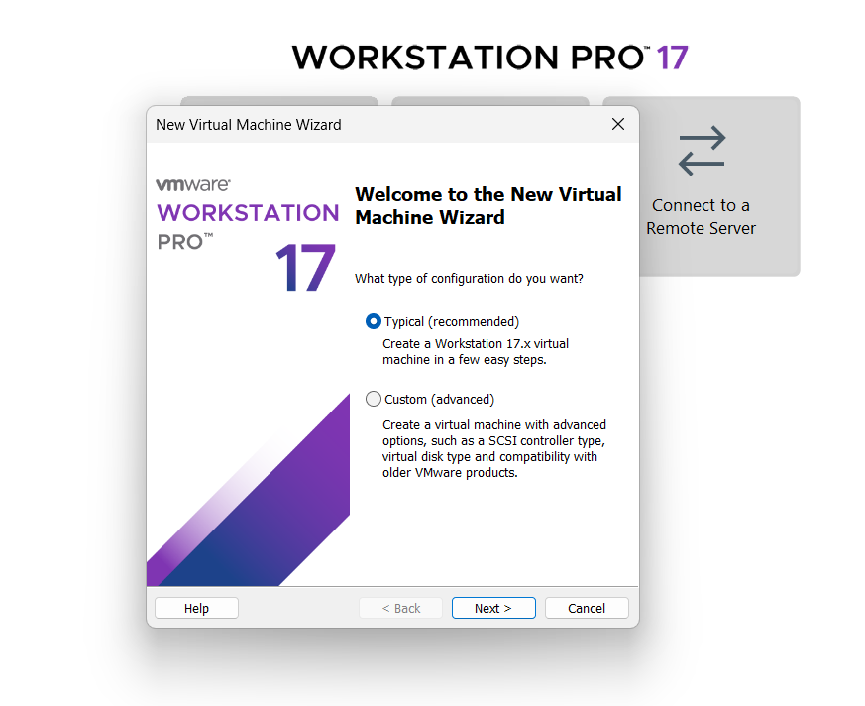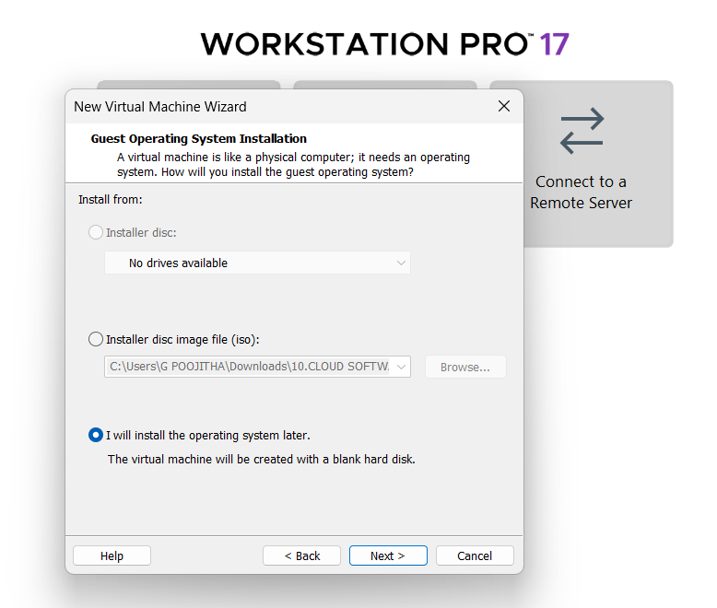
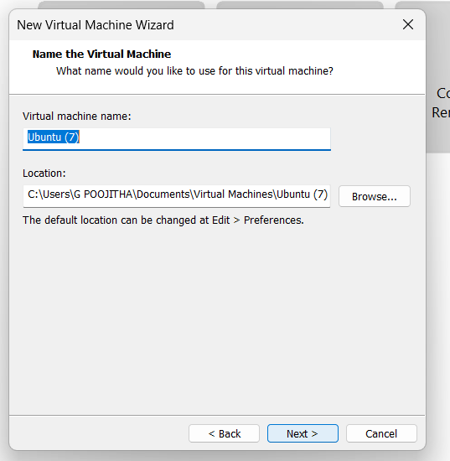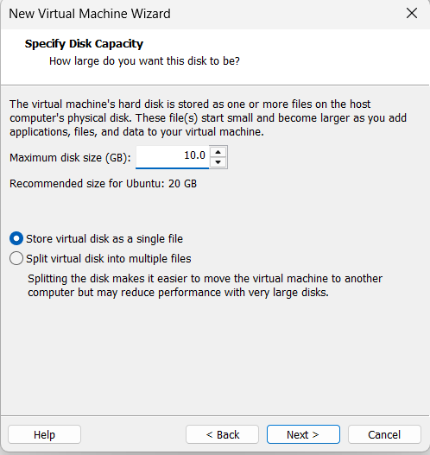
Name it anythingclick on nextAdjust the size of disk change the option to first and then click on next.
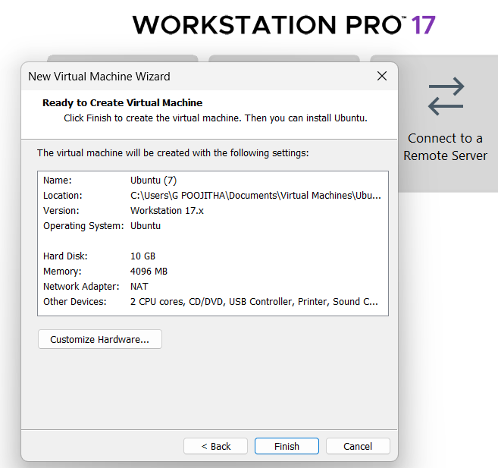 Click on Finish to Launch .
3.VM is created
